Name: SANKALP VERMA

Problem Statement : (Logical and Physical Model)

Using the wizard create the following schema:

Ans:

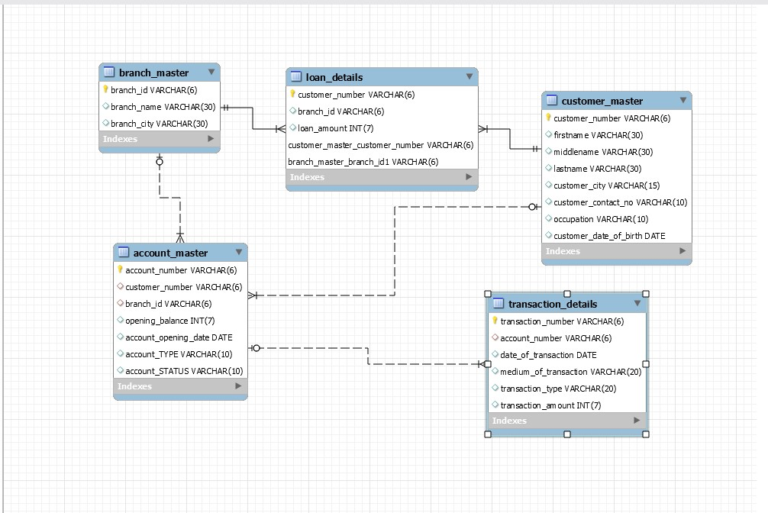

tables details are given below

